FIT3140 Assignment 2

PRoject Scope

Dekel Pilli & James Pickering

2017

Our Vision

We aim hope to create an application that manages a physical voting system, using a motion sensor to detect how many people can currently vote and a web application for voting. This application will be linked to a cloud-based database that will record voting information and the amount of clients and voters currently available.

# Project Scope

There are two main parts to this system: the motion sensor hardware/software, and the web application used to vote and display results. The motion sensor is connected to an Arduino microcontroller, which records motions, and sends them to a cloud-based Google Firebase database. Motions that last for 5 seconds or more indicate that a voter has entered a voting station, and motions under 5 seconds indicate that a voter has left a voting station.

The web application is notified every time the database is updated, and uses this sensor information, combined with data about how many people are voting, in order to regulate voting. For example, if the data indicates that 3 people have entered a voting station, then 3 people will be allowed to vote on the web app, and if 2 of those people vote, then only 1 person will be allowed to vote.

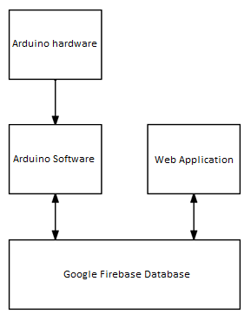

# Constraints

In addition to the requirement of the Arduino hardware, and the installation of the required packages, this application will require the user to be using a Linux or OSX device.